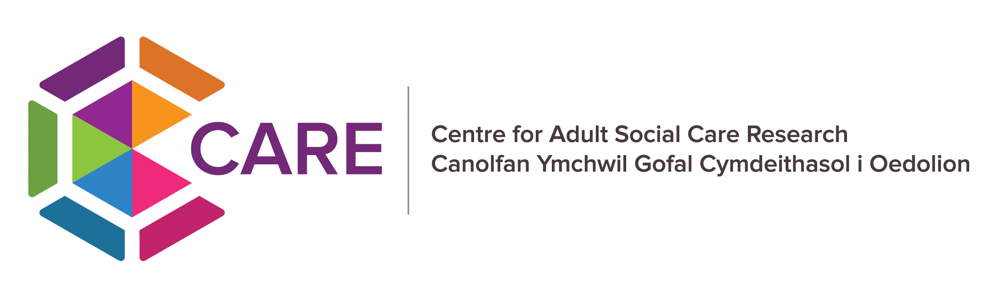 

**CARE Lab**  
**Centre for Adult Social Care Research**

**Join our Lived Experience Group**

**What is CARE Lab? -** CARE Lab is a new research project that will help improve adult social care in Wales. It will safely link anonymous data from social care, health, and other services to better understand who gets care and support, who doesn’t, and how things can be improved. By bringing these sources together, CARE Lab will give the most complete national overview yet of social care in Wales and help shape better services for the future.

**Who are we looking for?** - A group of people (up to 10 people) who have experience of using adult social care services, receiving care and support or being an unpaid carer in Wales, to join our Lived Experience Group.

This might include things like -

* Living with an impairment and/or health condition
* Being an unpaid carer
* Receiving care and support from:
  + Day centres, charities, and organisations
  + Domiciliary care (care at home)
  + Community Support
  + Care homes, nursing homes, and supported living

**What would I do as a member of the Lived Experience Group -**

* Attend 4 meetings a year (online and in-person)
* Help shape the CARE LAB project with your lived experience
* Share insights and give feedback as the project develops
* Gain new skills with free training and ongoing support
* Receive payment for your involvement (£25 an hour)

**You do NOT have to have any prior experience of research or of being part of an advisory group**

**Interested? To find out more**

Contact Miranda Evans, Business and Partnerships Manager, Disability Wales [miranda.evans@disabilitywales.org](mailto:miranda.evans@disabilitywales.org)

Contact Alice Butler, CARE Public & Professional Officer, [care@cardiff.ac.uk](mailto:care@cardiff.ac.uk)

