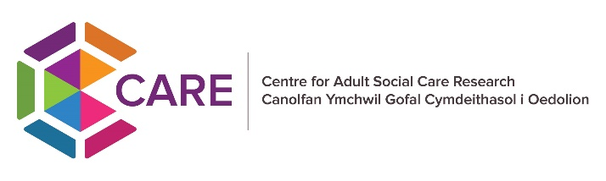

**Easy Read**

**Join our Lived Experience Group and be part of the CARE Lab Research Project  
  
An advert about the Lived Experience Group**

**What is CARE Lab?**

  
CARE Lab is a new research project

CARE Lab is being run by CARE. CARE is a research centre based at Cardiff University.



CARE stands for Centre for Adult Social Care Research.



The CARE research centre does research about how to make adult social care better in Wales.



The CARE Lab research project started on 1st of April 2025.

**What will CARE Lab do?**



It will look at lots of information about people who use social care support in Wales.



This information comes from different places that people use every day like:

* + Hospitals
  + Schools
  + Other support services



CARE Lab will join this information together and look at patterns and trends for lots of people.

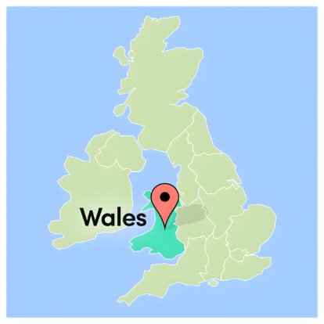

By looking at patterns, we can understand more about social care across all of Wales.



Understanding more in social care would help us learn things like:

* Who is getting care and support
* Who is not getting help
* What needs to be better

**Who can join the Lived Experience Group?**



We want to hear from **adults in Wales** who have used **adult social care services.**

**Using social care services can mean that you:**



Live with a health condition or impairment

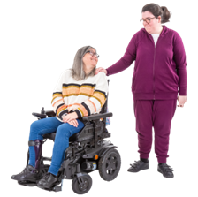

Look after and care for someone without being paid

Get support from a day centre, charity or other group.

Have care workers support you at home.

Live in supported housing.

Live in a care home or a nursing home.



This is not a full list.

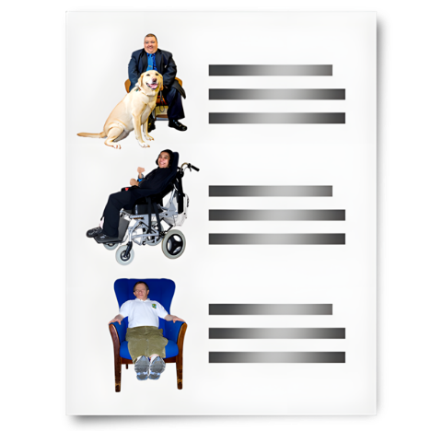

There are lots of other reasons why people have lived experience of social care.

**What will I do in the Lived Experience Group?**



Go to 4 meetings each year.



Some meetings will be in person in Cardiff.



Some will be online meetings.

You will help the CARE Lab research project by sharing your real-life experiences of having care and support.

You will give ideas and feedback to make the research project better.

You will learn new skills with free training and support.



Get paid £25 an hour, in voucher form or by bank transfer.

All your travel to and from meetings will be paid for by CARE Lab.

Everyone with lived experience of adult social care is welcome to join.



You do not need to have experience in research or being in a group like this before.

**Would you like to join the Lived Experience Group?**

**All you need to do is:**

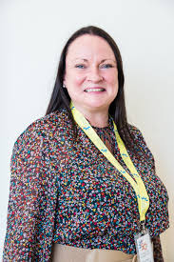

Email Miranda Evans**,** from Disability Wales - [miranda.evans@disabilitywales.org](mailto:miranda.evans@disabilitywales.org).

Miranda is the head of this group.



Email Alice Butler**,** from CARE - [care@cardiff.ac.uk](mailto:care@cardiff.ac.uk)

Alice is there to support this group.



**Who made this document?**



Easy read document created by Alice Butler -

Public & Professional Involvement Officer  
Centre for Adult Social Care Research Centre (CARE)

Email - [butlera7@cardiff.ac.uk](mailto:butlera7@cardiff.ac.uk)

